**Quiz No.2 PLEASE SUBMIT ON SLACK by 1:40 PM**

October 25 , 2021

Please circle around your major: **Computer Science**  or **Computer Engineering**

**NO CORRECTIONS ARE ALLOWED on FRONT page!!!!!**

You may use the back page for computations. Please answer all questions. **Not all questions are of equal difficulty.**

**Please review the entire quiz first and then budget your time carefully.**

*MAX NUMBER OF POINTS YOU CAN GET IN THIS TEST IS 100.*

***SIGN:***

***NOTE: Answers given without justification - NO CREDIT FOR THE QUESTION!!!!!***

**Question 1. ( 30 Points) Memory model is a linear array of bytes, as shown in Figure 1. The minimal addressable unit in this memory is one byte. Below, Figure 1. depicts a small part of such a memory. The absolute address 0x80000100 is used as a base address and is stored in a register RBase** **. For clarity, this address is depicted to the left of the corresponding byte.**

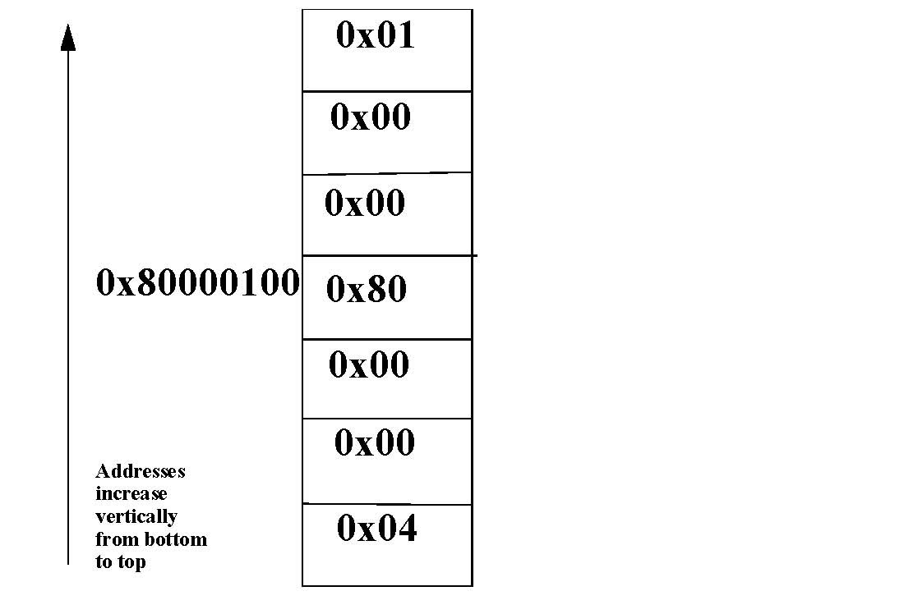

**Figure 1.** Memory model is a linear array of bytes.

Q.1.1. [5 points] Assume you have a MIPS processor and associated memory, as shown in Figure 1. What is the signed decimal value of the 32 bit integer (word) at the address0x80000100?

-2^31 + 1 is the signed dec value, mips is big endian and 0x80 is most sig and 0x01 is least sig.

1 0000000 0000 0000 0000 0000 0000 0001 = -2^31 + 1

Q.1.2. [5 points] Assume you have an INTEL i7 processor and associated memory, as shown in Figure 1. What is the signed decimal value of the 32 bit integer (word) at the ad-dress 0x80000100?

2^24 + 2^7 because intel is little endian so most sig bit is -2^31 and 0x01 is least sig.

00000001 00000000 00000000 10000000 = 2^24 + 2^7

Q.1.3. [5 points] what is the address of a byte containing 0x01?

Based on figure 1, 0x80000103, 3 address values from base pointer

Q.1.4 [5 points] what is the offset from base address (stored in Register RBase) to the byte containing 0x01?

+3, 3 addr up from base pointer

Q.1.5. [5 points] what is the address of a byte containing 0x04?

08x800000FD, 3 addr from bottom

Q1.6 [5 points] what is the offset from base address (stored in Register RBase) to the byte containing 0x04?

0x80000100 – 0x800000FD = -3

# Question 2. ( 25 Points)

You are given an instance of a program in MARS MIPS simulator window.

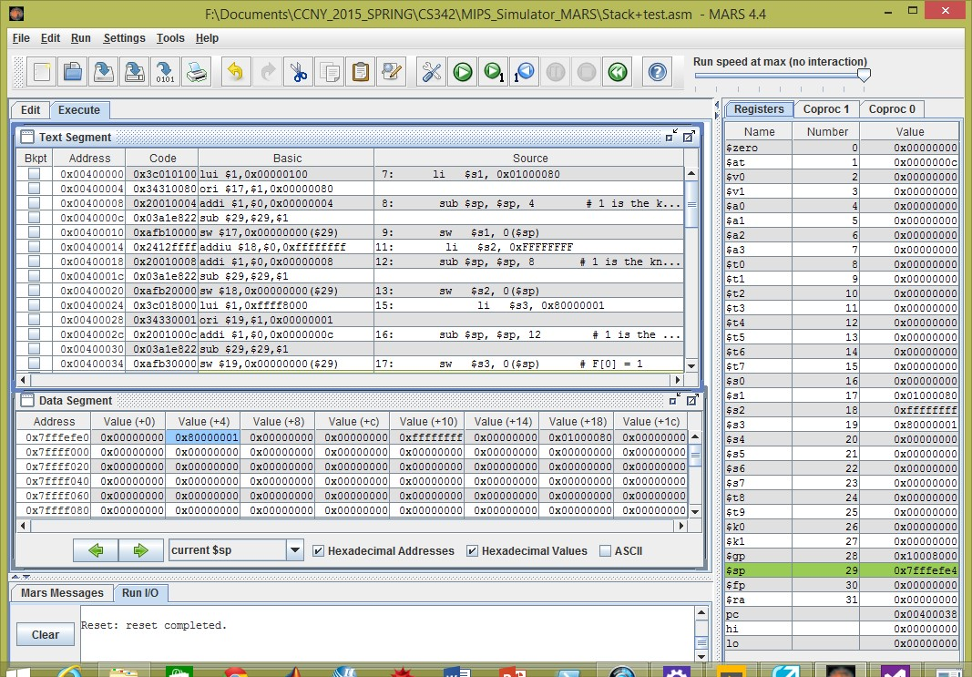

2.1. [5 points]What is the signed decimal value of the integer on top of the stack.?

$sp = 0x7fffefe4 = 0x7fffefe0 + 4 = 0x80000001 = -2^31+1

2.2 [5 points]What is the value stored in stack pointer register?

$sp = stack pointer = 0x7fffefe4

2.3.1 [2.5 points]Compute the address of an integer stored on the stack at offset **+12** from the stack pointer.

0xe4 + 0x0c = F0 = 1111 0000

2.3.2 [2.5 points]What is the signed decimal value of the integer at this location?

-1, 2’s complement 0xffffffff = 000…01 = -1

2.4.1 [2.5 points]Compute the address of an integer stored on the stack at offset **+20** from the stack pointer.

0xe4 + 0x14 = 0xf8 = 1111 1000

2.4.2 [2.5 points]What is the signed decimal value of the integer at this location?

2^7 + 16^6 + 8 x 16 = 0x10000080

2.5[5 points] Can you determine the address of the instruction that will be executed next step? If yes, please write it down.

0x00400038, look at pc reg

## Question 3. (35 points)

**You are using MS Visual Studio development environment. The processor is Intel i7.**

**In DEBUG mode you display REGISTER, DISASSEMBLY, and MEMORY windows.**

**Please answer the following questions based on the information displayed in the DEBUG mode windows.**

1. *(1 points)* What is the content (what number is stored in EBP) of the base pointer register EBP?

0x006CF9E4, look in register EBP

1. *(1 points)*Can you specify the Memory window # where partial ***Stack Frame*** is displayed? If YES , please YES and give the window #. If **No,** Please write NO.

Yes, Window #3

1. *(10 points)*Based on the information shown in the screenshots, can you determine if variable ***m*** is static or local? Please circle around your choice word. If it is possible, to answer questions

Local, in disassembly window it is in the stack

* 1. What is the offset from base pointer to local variable ***m*** on the stack?

0xd4 = 1101 0100 = -128 + 88 = -44

* 1. Please list all absolute addresses to the **offsets of** variable ***m*** as used in instructions the program:

0x00EB13D5 = 0x00eb13d3 + 0x02 = 0x00eb13d5

0x00EB13DF = 0x00eb13dd + 0x02 = 0x00eb13df

* 1. What is the address of local variable ***m*** on stack?

0xe4 + 0xd4 = 1011 1000 = 0xb8

* 1. What is the signed value (in DECIMAL) of local variable ***m*** as you can observe on ***Stack Frame***?

Int m = EFFF FFFF in disassembly. EFFF FFFF = -2 in 2’s complement

1. *(10 points)*Based on the information shown in the screenshots, can you determine if variable ***quizint*** is static or local? Please circle around your choice word.

Local, it is in the stack

* 1. What is the offset from base pointer to local variable ***quizint*** on the stack?

0xf8 = 1111 1000 = -8 in 2’s complement

* 1. Please list all absolute addresses to the offsets of variable ***quizint*** as used in the program:

0x00eb13be + 0x02 = 0x00eb13c0

* 1. What is the address of local variable ***quizint*** on stack?

0xe4 + 0xf8 = dc, offset + EBP

* 1. What is the signed value (in DECIMAL) of local variable ***quizint*** as you can observe in ***Stack Frame***?

0x006cf9dc = 0x01000050 = 2^24 + 2^7

1. *(10 points)*Based on the information shown in the screenshots, can you determine if variable ***MIPSInt*** is static or local? Please circle around your choice word.

Local variable, it in stack

* 1. What is the offset from base pointer to local variable ***MIPSInt*** on the stack?

0xe0 = 1110 0000 = -32

* 1. Please list all absolute addresses to the offsets of variable ***MIPSInt*** as used in the program:

0x00eb13ce = 0x00eb13cc + 0x02

* 1. What is the address of local variable ***MIPSInt*** on stack?

0xe4 + 0xe0 = c4 = 1100 1100 🡪 0x006cf9c4

* 1. What is the signed value (in DECIMAL) of local variable ***MIPSInt*** as you can observe in ***Stack Frame***?

Addr 0x006f9c4 = 0x80000001 = -2^31 + 1

1. *(1 points)*Can you determine the address of the instruction that will be executed next instance?

0x00eb13dd, look at EIP

1. *(1 points)*What is the assembly code length in bytes?

Last IP – first IP + 1 = EB – A0 + 1 = 1000 1011 = 76

1. *(1 points)*Can you determine the number of instruction of length 7 bytes? If yes, What is it?

00eb13be, 00eb13c5, 00eb13cc, 00eb13d3.. look at disassembly window

1. *(1 points)*Can you determine the number of instruction of length 6 bytes? If yes, What is it?

00eb13a3, 00eb13ac, look at disassembly window

1. *(1 points)*Can you determine the number of instruction of length 5 bytes? If yes, What is it?

00eb13b2 and 00eb137, look at disassembly window

**Question 3. ( cont'd )**

|  |  |  |
| --- | --- | --- |
|  |  |  |

**Question 3. ( cont'd )**

|  |  |
| --- | --- |
|  |  |

***In EACH Questions 4.1-4.2 you are given SIGNED Integers stored in 16 BIT Registers. If there is an overflow, please indicate.***

* 1. **[5 points]** What is the result (hexadecimal, decimal and binary) of the following subtraction:

0x7FFF

-

0xFFFF

HEX: -8000

Decimal: 32767 – -1 = 32768

Binary: 0111111111111111 – 1111111111111111 = 1000 0000 0000 0000

overflow [-32768, 32767]

* 1. **[5 points]** What is the result(hexadecimal, decimal and binary) of the following addition:

0x7FFF

**+**

0xFFFF

HEX: 17ffe

Decimal: 32767 + -1 = 32766

Binary:

0111111111111111 + 1111111111111111 = 0111 1111 1111 1110

No Overflow, [-32768, 32767]